**REQUIREMENTS AND MAIN USE CASES**

**TOP 5 FUNCTIONAL REQUIREMENTS:**

1. A user should be able to input a list of stops.
2. The system should generate a path between the stops.
3. The path should be feasible and somewhat optimized.
4. The path should have clickable detail view for each stop.
5. The path should also display distance and time between each stop.
6. The address must be a in the United States and have a standard postal code. (Copied from Non functional).

**TOP 5 NON-FUNCTIONAL REQUIREMENTS:**

1. The address must be a in the United States and have a standard postal code.
2. The program must be written in Java.
3. The program cannot make you violate local laws or safety (trespassing).
4. Process development will initially using the waterfall method and change to agile method.
5. The path must be generated within a few seconds (user acceptability).
6. The path must be generated with minimal backtracking as the first priority

**MAIN USE CASES:**

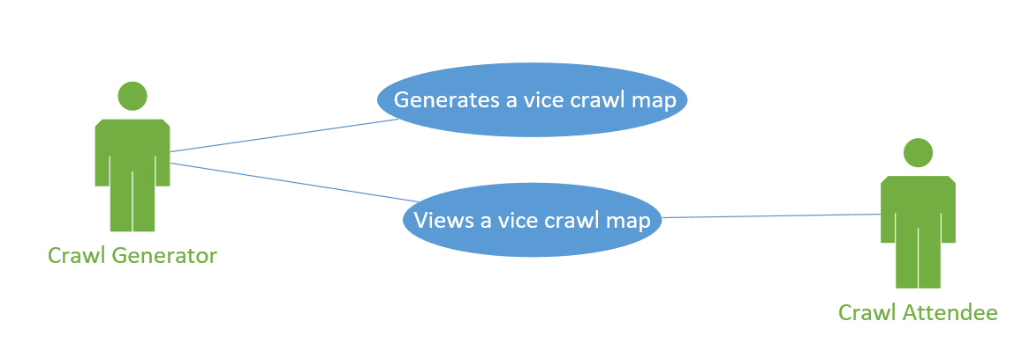

A crawl generator can input a list of places. A crawl will be generated. The crawl generator can publish the crawl. The crawl attendee can view the crawl.